LangChain LCEL Chaining Method

LCEL stands for LangChain Expression Language and it is a pattern for building LangChain applications ​that utilizes the pipe (|) operator to connect components. This approach ensures a clean, readable flow of data from input to output.
​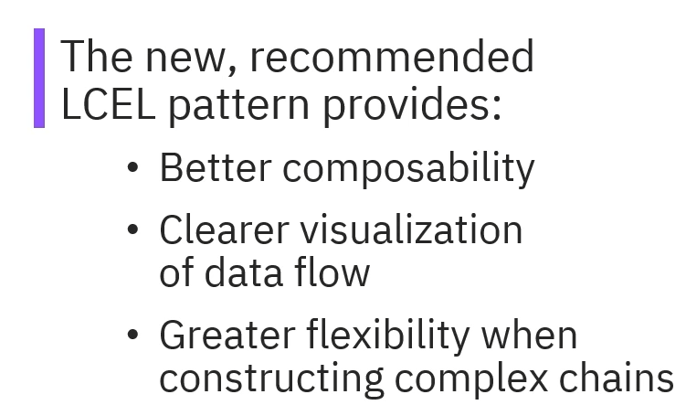
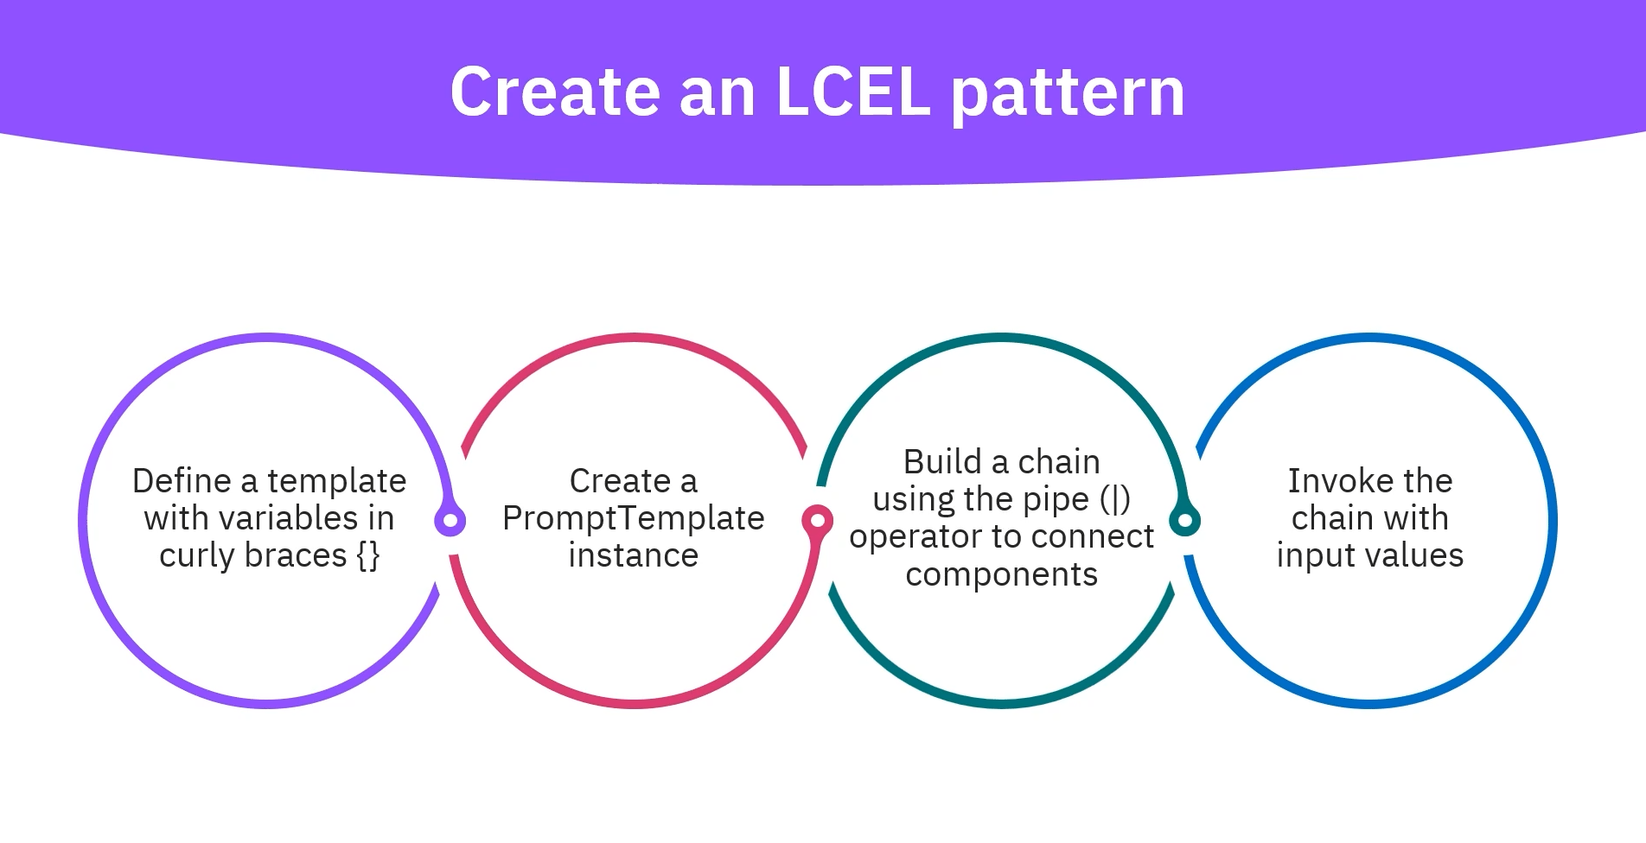
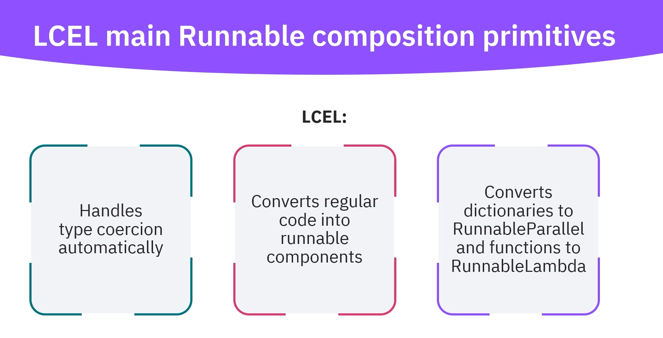
What are Runnables? ​In LangChain, runnables serve as an interface and building blocks that connect different ​components like LLMs, retrievers, and tools into a pipeline.
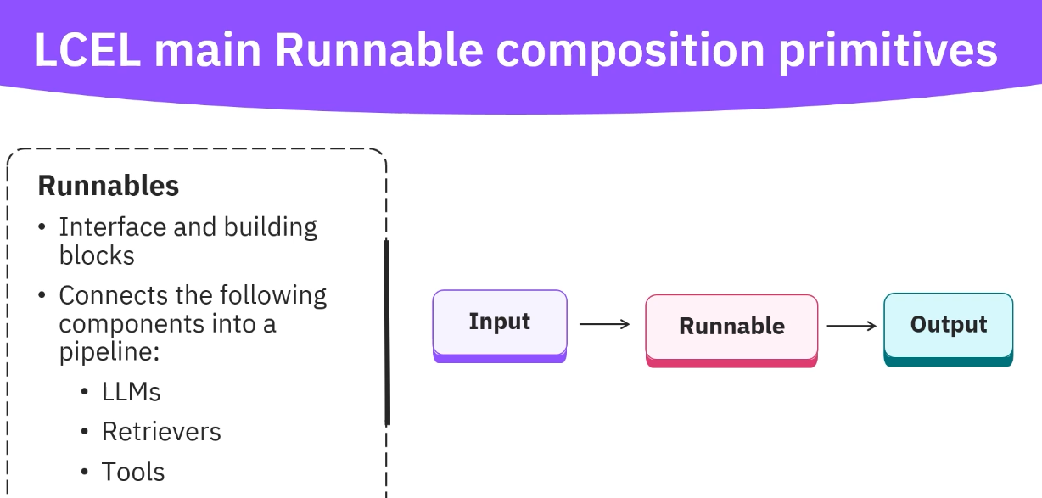
There are two main runnable composition primitives:
Runnable sequence chains components sequentially, passing the output from one component as input to the next. 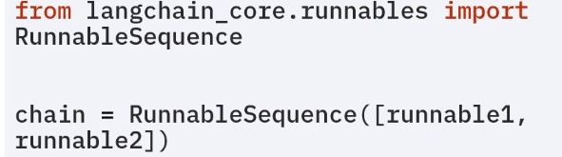
​Runnable Parallel runs multiple components concurrently while using the same input for each. 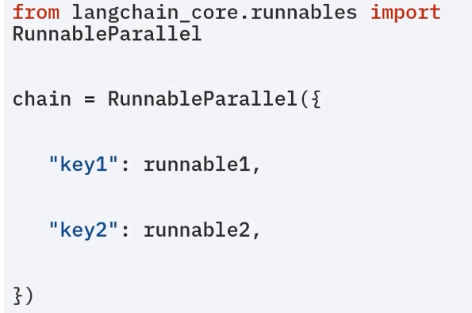

However thanks to LCEL we can use the pipe operator we have a simple syntax by ​simply connecting runnable 1 and runnable 2 with a pipe, making the structure more readable and intuitive. 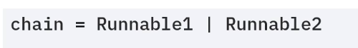
In LangChain, a Runnable is basically anything that can take an input → process it → return an output.
Think of it as a standard interface for components that “run”.

Simple Definition
A Runnable is an object that implements a .invoke() method and can be executed with some input.
result = runnable.invoke(input)

Why LangChain introduced Runnables
Earlier LangChain had many separate concepts:
- Chains
- LLMs
- Tools
- Retrievers
Each had different ways of running them.
So LangChain introduced Runnable Interface so everything works the same way.
Now you can run almost anything using:
.invoke() # single input
.batch() # multiple inputs
.stream() # streaming output

Example 1 — LLM as a Runnable
from langchain_openai import ChatOpenAI
llm = ChatOpenAI()
llm.invoke("Tell me a joke")
Here llm is a Runnable.

Example 2 — PromptTemplate as Runnable
from langchain_core.prompts import PromptTemplate
prompt = PromptTemplate.from_template(
"Tell me a {adjective} joke about {topic}"
)
prompt.invoke({
"adjective": "funny",
"topic": "chickens"
})
This returns a formatted prompt string.
So PromptTemplate is also a Runnable.

Example 3 — Chaining Runnables
You can pipe runnables together using |.
chain = prompt | llm
chain.invoke({
"adjective": "funny",
"topic": "chickens"
})
Flow becomes:
input → PromptTemplate → LLM → output

LCEL also handles type coercion automatically. This means it converts regular code into runnable components. ​When you use a dictionary, it becomes a runnable parallel, which runs multiple tasks simultaneously. ​When you use a function, it becomes a RunnableLambda, which transforms inputs. ​This happens behind the scenes, so you don't have to handle the conversion manually.
https://chatgpt.com/c/69b44bd3-e570-8320-95ad-42c647b567e3

